**Assignment -14**

Question 1 : Explain the below DockerFile

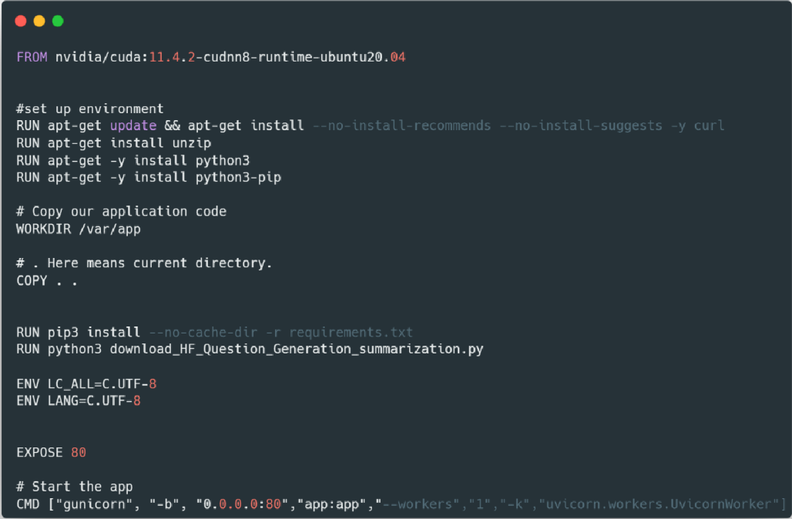

**Ans:**

1. Define the base image with FROM

Every Dockerfile must start with the FROM instruction. The image you start from is called the base image.

**Here are the explanation of the steps:**

Always start with base image, here we are suing nvidia/cuda as Docker image.

* We are using the official Nvidia Cuda image based on Ubuntu.
* We setup Python related and other necessary libraries, as well as add pip.

The **RUN** command used to run command on base image. We are updating the OS and installing necessary packages like unzip, python3, python3-pip.

* Make /var/app as default directory.

The **WORKDIR** command is used to define the **working directory** of a **Docker** container at any given time.

We are changing the working directory to /var/app

* Copy the source from project directory to Docker.

The **COPY** command is used to copy the files from the host system in to the image.

We are copying all files from current project folder to current working directory i.e. /var/app.

* Install Requirements.

The **RUN** command is now installing all the dependencies from requirement.txt file,

--no-cache-dir is to disable the caching to reduce the image size.

* Next **ENV** command is setting up the environment variable.
* The **EXPOSE** instruction informs Docker that the container listens on the specified network ports at runtime. We are using port number 80.
* Run the command to run the project.

**CMD** is used to execute commands. Here it is using gunicorn which is webserver gateway and running the application on 0.0.0.0:80.

• app:app means python module name “app” and another app after colon is variable so it is like from app import app • --workers is the number of worker processors here it is 1 worker